Best World Music Albums of 2009 by JPR
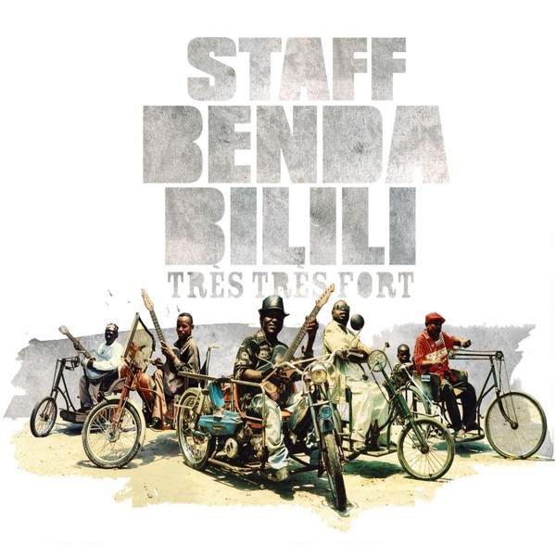 | Staff Benda Bilili | Très Très Fort | Crammed Discs
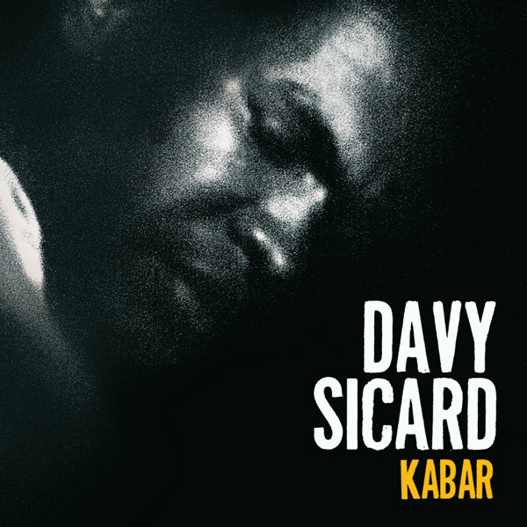 | Davy Sicard | Kabar | Warner Music France
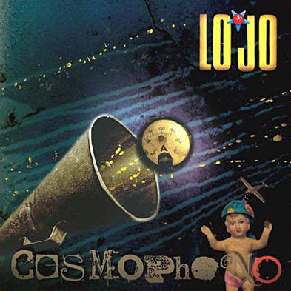 | Lo’Jo | Cosmophono | Wagram Music
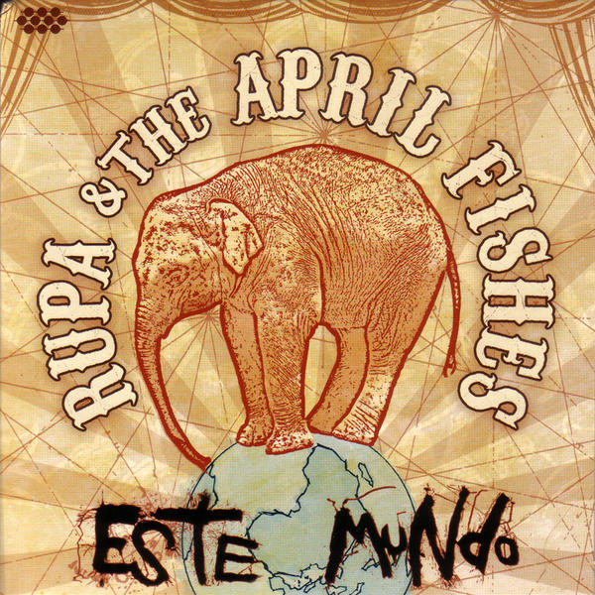 | Rupa & The April Fishes | Este Mundo | Cumbancha / Virtual
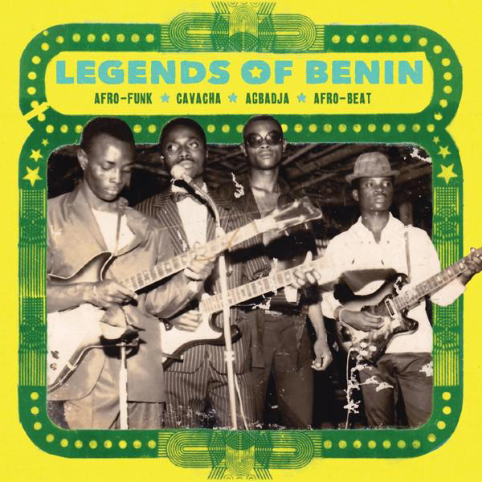 | Various | Legends Of Benin | Analog Africa/Believe Digital
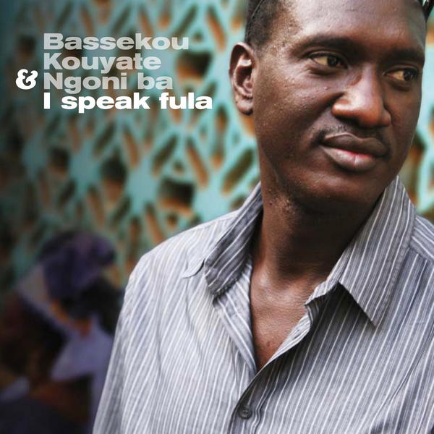 | Bassekou Kouyaté + N’goni Ba | I Speak Fula | Out Here / Morr Music GBR
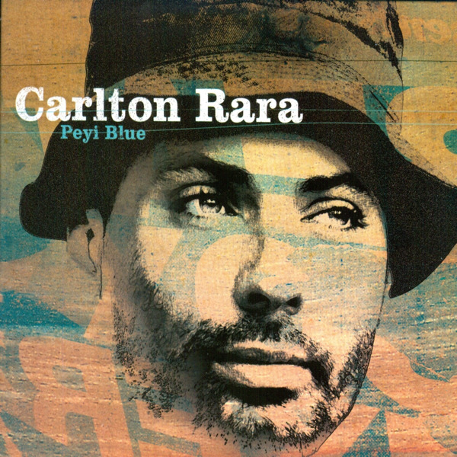 | Carlton Rara | Peyi Blue | Iris Music
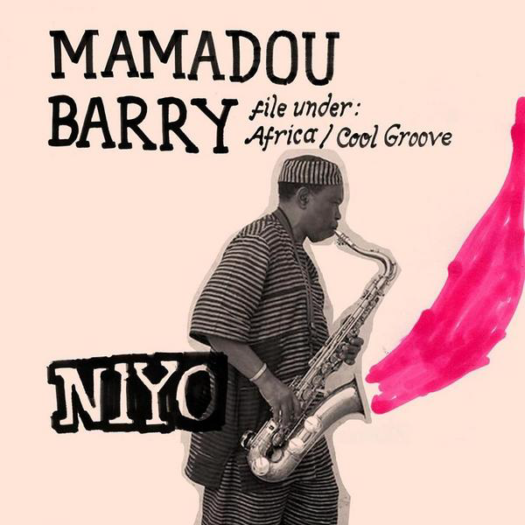 | Mamadou Barry | Niya | World Village France/IODA
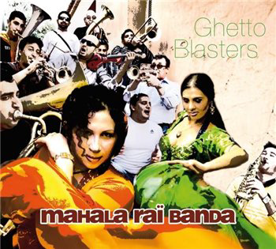 | Mahala Rai Banda | Ghetto Blasters | Asphalt Tango
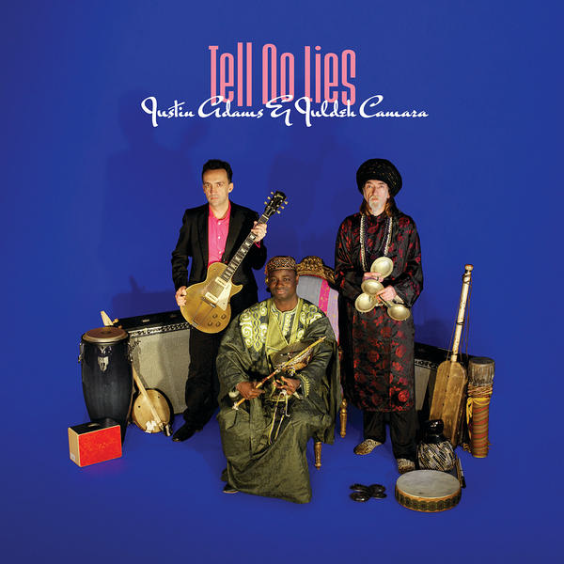 | Justin Adams & Juldeh Camara | Tell No Lies | Real World

